Name:  Class: | ____________________________________  ________________ |  | Date: _________
 | Year 7 Mathematics - Modified  End of Term 1 Test, 2018  Topic – Directed Numbers, Index Notation |  | / 42  %
Total Time: | 55 minutes
Weighting: | 10 %
Equipment: | 1 A4 Page of Notes (1 side), Calculator for Calculator Section
Notes: | Show working and answers on this sheet. Show working in sufficient detail to support your answers. Incorrect answers without supporting reasoning will be allocated zero marks.

Non-Calculator Section

Question 1 2 marks

Circle the largest number and underline the lowest number

- -6 -4 9 -12 2

- 0 15 -2 -21 19

Question 2 2 marks

Order the following from lowest to highest:

-2, 6, -6, 3, 1, -1, 0 ____________________________________

Question 3 2 marks

Indicate which is integer is largest by placing either a < or > in between each set of numbers:

- -7 ___ -12 b) -5 ___ 4

Question 4 4 marks

Complete the following:

  - 2 + (- 3) = __________
- (- 5) + 2 = __________

- 8 - 3 = __________

  - 12 – (- 11) = __________

Question 5 4 marks

Use the symbols <, > or = to complete the number sentences.

- 12 + 27 ____ 21 + 18 c) 2² + 4² ______ 5² x 2

- 3 x (2 + 5) _____ 3 x 2 + 3 x 4 d) (3 + 5) – 4 _____ 3 + (5 – 4)

Question 6 2 marks

The minimum temperature in the city of Destiny was -12ºC.

It increased by 5ºC and then increased by 9ºC to reach its maximum.

What was this maximum temperature?

Question 7 2 marks

Complete the table.
Index Form | Expanded Form
 | 2 x 2 x 2 x 2
 | 10 x 10 x 10 x 10 x 10 x 10
5³

12⁵

Question 8 3 marks
Find the answer of the following squared numbers.

Index Form | Answer
3²
10²
4²

Question 9 7 marks

Use a factor tree to find the prime factors of 20 and 48.

20 48

The Prime Factors of 20 = ___________________

The Prime Factors of 48 = ___________________

Question 10 3 marks
Evaluate the following square roots

- $\sqrt{16}$ =

- $\sqrt{25}$ =

- $\sqrt{100}$ =

Year 7

End of Term 1 Test

2018


Name: _______________________________
Calculator Section

Question 11 6 marks

Find the Perimeter and Area of the following shapes. The distance between the dots is 1cm

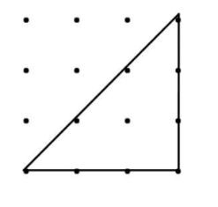
a) b) c)
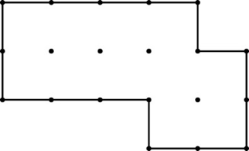
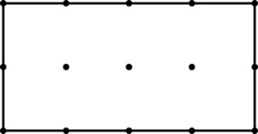

Perimeter = Perimeter = Perimeter =

Area = Area = Area =

Question 12 3 marks

Find the area of the following shapes. Show your work

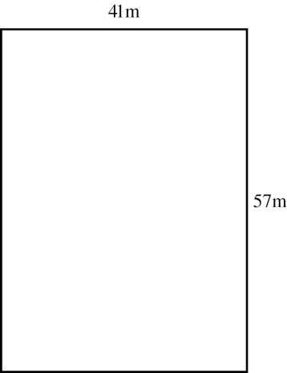
a. b.
5 cm
8 cm

8 cm

c.
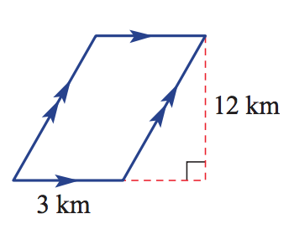

Question 13 2 marks

Two hundred square tiles, each measuring 10 cm by 10 cm, are used to tile an open floor area.
Find the area of flooring that is tiled.

END OF TEST

